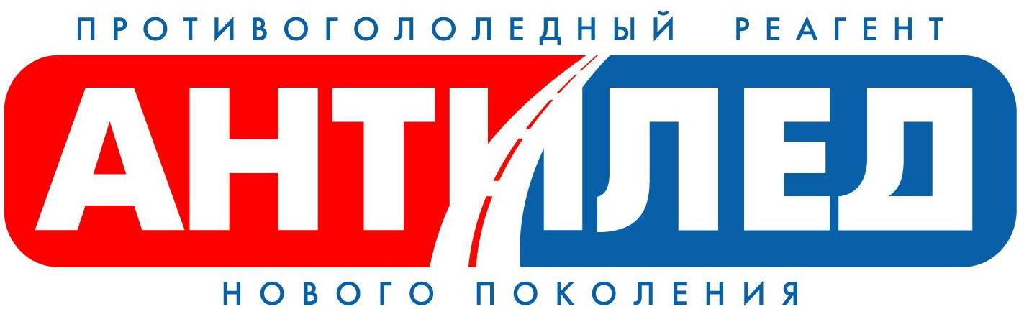
5, 1/14, B.Palashevsky, Moscow, 123104
Office – 34 B, Sofiyskaya nab., Moscow, 115035
Tel/ph 951-83-47, tel. 951-80-95
E-mail: antiled@gmail.com

SPECIAL OFFER

“Antiled” Company offers co-operation to distributors

We offer:

- A possibility to provide your customers with the unique products: the deicing products "Anti-Ice" of the new generation.
- Wholesale prices with the flexible discount system.
- Payment after the products sale.
- The size of the product lots (both maximum and minimum) is not limited.
- Package providing the comfort and the safety of goods during delivery.
- Delivery of goods in Moscow is made by OUR COMPANY’S TRANSPORT.

The advantages of co-operation with “Antiled” company:

Our experience:

“Antiled” Company for many years has been successfully co-operating with the gross hypermarkets, fuel stations, bancs, cinema theatres, hotels, shops and other legal and natural persons.

Our quality:

“Antiled” Company puts into practice the program of Moscow Government concerning the care, health and well-being of the citizens and ecology of the city, implements the recent eco-friendly and safe materials to struggle against the winter lubricity.
All our goods are certified and there are all necessary Health Certificates.

Our assortment:

- Solid deicing product “Anti-Ice” (bottle of 5 L)
- Liquid deicing product “Anti-Ice” (bottle of 1000 ml equipped with the dispenser PUSH-PULL)

“Antiled” Company is a manufacturer and is ready to supply our goods in any quantities anytime.

If you wish to receive more detailed information about co-operation with our company, please contact the phone number:

+ 7 495 363 75 37

E-mail: antiled@gmail.com
www.antiled.biz

